WEDE5020
Livhuwani Singo
ST10526881
PRESENTED TO: SAM JWARA
WEB DEVELOPMENT


Organisation Overview 2
Vision Statement 2
Mission Statement 2
Target audience 2
Goals and Objectives 2
Key performance indicators 2
Current Website Analysis 3
Areas of improvement 4
Features and functionality 4
Design and User experience 4
Colour Palette 4
Typography 4
Layout and Design 5
Technical Requirements 5
Domain Registration: 5
Web Hosting 5
Programming Languages and framework 5
Timeline and Milestones 5
Budget 6
References 6

Organisation Overview
Here is the best new in café in the streets of Rosebank. Established in 2025, to bring the love of coffee, local artists and wellness together. A shared canvas painted with deep connection, fuelling a vibrant community beyond home or office (HERE., 2025).

Vision Statement
To create a third-space, not home or the office, but something in the middle. A home for creation, work and inspiration, all served with the ones perfect cup of choice. Where big ideas are born.

Mission Statement
Combine people from all sphere over a love community, art and work. A reminder that you are not alone, everyone is up grinding is willing to lend and ear. It all starts here.

Target audience
Students, Corporate baddies and Mrs, artists, health fanatics, and all who feel a sense to creativity and want to be around like-minded individuals.

Goals and Objectives
- Provide extensive information and content about the business
- Update website interface and styling to better suit the user’s appeal (increase customer satisfaction)
- Increase site traffic. The same momentum observed on the business’s other social platforms, website traffic is just as important
- Better sell the vision and mission of the business along with the products offered
- Have an effective search engine result

Key performance indicators
- Time spent/session: how much time do users spend on the website and what is the frequency of the visit to the site. This helps identify user behaviour and habits.
- Page load time: Fast loading webpages impact user experience and revenue for the business. This will also help identify which webpages take the longest to load.
- Unique website visitors: this will help give an overview of website performance, determine what is the size of the audience the business is reaching and the rank of the website in search results.
- Bounce Rate: A lower bounce rate means more consumers are interested in the content provided and the business. This indicates that the business has found its target audience

Current Website Analysis
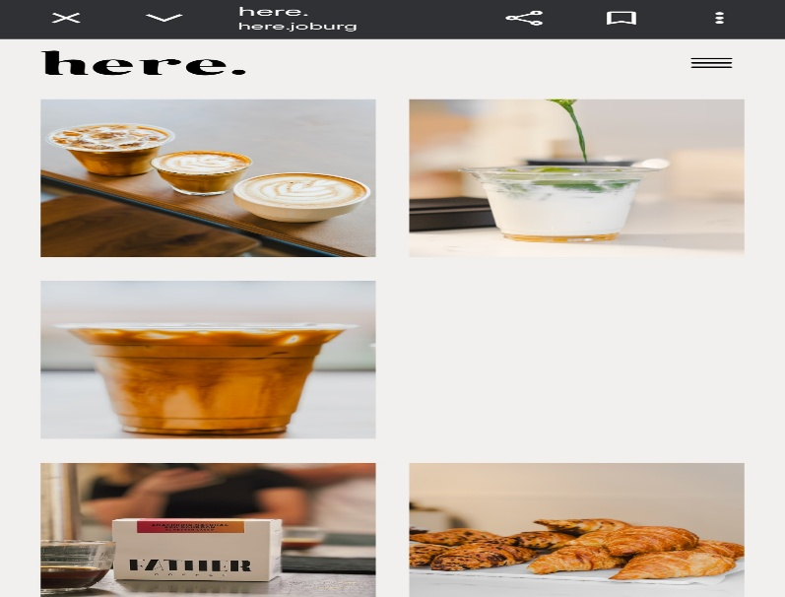
Figure 1: Current Website
STRENGTHS | WEAKNESSES
- Consistent formatting – The uniform text style across all pages to improve readability. | - Limited information – Missing critical about us details, such as mission/vision statement and current team
- Accessible contact info: Clear physical address, email and linked social media account. | - Poor layout spacing: imagery placement is unappealing, with excessive white space and gaps between elements
- Partnership transparency: Visibility regarding current sponsors. | - Missing operating hours: There is no mention of when the café opens.
- Good navigation: Well-structured navigation pane, easy to find key sections | - Unstructured menu: Lacks categorization, which makes it difficult to browse offering.

Areas of improvement
- Visual design and layout
- Clear identification strategy
- Operating Hours
- Mena layout

Features and functionality
- Homepage- Hero image, brief introduction of business, navigation pane, current images
- Explore- Menu options offered
- Feed- Collaborations, yoga sessions, run/walk club dates, entertainment nights
- About us- Founders, vision/mission, team, history of business, career opportunities
- Contact- Physical address, contact number, email and social media links

Design and User experience

Colour Palette

Figure 2: Website colour palette

Typography
The website will prioritise readability and good navigation through clean imagery and minimal styling. We will utilize Cascading Style Sheet (CSS) to implement sophisticated visual layout and ensure well-integrated aesthetic across the entire platform. Furthermore, images will be well sized to establish a clear visual hierarchy, to guide the user’s attention to the most important content.

Layout and Design

Figure 3: SITE MAP

Technical Requirements

Domain Registration:
This website will be registered with a .joburg extension. This will ensure a localised digital presence, improve search relevance and build trust with the target audience.
Web Hosting:
The platform used will be Afrihost. This provider is selected for its high performance infrastructure, which will ensure optimal loading speed for all users.
Programming Languages and framework:
- Html5-The skeletal structure of the website. It defines the content of the page.
- CSS- The styling of the website. It is the visual presentation of the website and ensures that the website looks professional on all devices.
- JavaScript- The functionality of the website. It is what makes the website perform specific actions.

Timeline and Milestones
Phase 1: Research and Analysis
Duration: 1 Week
Conduct an audit of the organisations current digital presence and identify operational needs. Document the specific impact the business faces from their lack of a centralised website.
Phase 2: Proposal and feature definition
Duration: 3 Days
Develop a formal website proposal highlighting the competitive advantages of a digital transition. This phase includes a SWOT analysis and a detailed roadmap of recommended feature.
Phase 3 – Development and content integration
Duration: 1 Month
Create an html website, and integrate all organisational requirements identified in Phase 1
Phase 4: Testing and quality assurance
Duration 3-5 Days
Ensure that the website has good response on all mobile devices. Verify that all forms actually work and check for any broken link.

Budget
BUDGET | PRICES
Website build | R15000
Domain | R2000
Hosting | R1000
Images and graphics | R1000
Maintenance and Security | R4000
TOTAL | R23000

References
HERE., 2025. HERE.. [Online]
Available at: https://here.joburg/
[Accessed 11 MARCH 2026].
Madehatter, 2026. Color-hex. [Online]
Available at: https://www.color-hex.com/color-palette/89683
[Accessed 11 march 2026].
Vaiciunaite, D., 2022. Top 10 website kpi's to measure our clients website performance. [Online]
Available at: https://whatagraph.com/blog/articles/website-kpis
[Accessed 11 march 2026].

